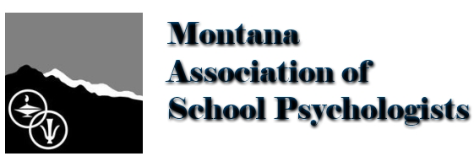
4/9/2020
RE: Virtual Service Delivery during COVID-19 Closures
In response to the COVID-19 pandemic, and in light of a declared national emergency, MASP is aware of the significant impact that mandatory school closures have on the learning and well-being of all children, and the various ways districts are attempting to provide supplemental learning opportunities to students., During this unprecedented time, we recognize that the physical and psychological well-being of students, families, educators and communities are the immediate and overriding priority. Thus far, the U.S. Department of Education (USDE) has issued various guidance documents which include the Office of Special Education Programs (OSEP) interpretations regarding the IDEA and the Office of Civil Rights (OCR) interpretations regarding 504/ADA.
As we prepare for shifts in school psychologist service delivery during this COVID-19 school building closure, the Montana Association of School Psychologists (MASP) in conjunction with the Office of Public Instruction (OPI) is issuing guidance regarding responding to the COVID-19 crisis with virtual service delivery. This guidance ceases once school buildings re-open.
Virtual service delivery is defined as providing services remotely, where the School Psychologist and the client (student, parent, staff, etc.) are physically located in two different locations and services are provided using technology via the Internet. It is also commonly referred to as teletherapy or telehealth.
With regard to legal mandates, ethical assessment, and decision-making practices it is currently considered acceptable practice to conduct Evaluation Team Meetings, Individualized Education Plan meetings, and Team Problem solving meetings/Consultations via virtual means, so long as the parent agrees to the virtual service delivery. Parents should be informed of the possibility of breeches in confidentiality prior to holding these meetings, with the conversation and parent approval/denial being documented. It is also currently acceptable during this time for a Montana School Psychologist who holds a valid Class 6 licensure to provide direct services. Such direct services may include counseling documented in the student’s IEP and mental health services. Due to the likely limited availability for supervision, it is not recommended that Montana School Psychologists holding a Class 5 licensure provide direct services at this time. As always ethical and legal considerations need to be adhered to if the decision to use virtual means for services is made. Current considerations should include the practitioner’s competency and training for virtual service delivery, internet access and bandwidth for staff and students, environmental set-up (headphones/privacy/distractions), age & functioning of the student, student characteristics/behaviors, and documentation of informed consent.
With the same regard to legal mandates, ethical assessment, and decision-making practices it is currently NOT considered acceptable practice to conduct direct observation and certain assessments through means other than face-to-face. A comprehensive and individualized evaluation, initial or reevaluation, requires direct classroom based observation of the student in the child’s learning environment. Assessments must be administered by trained and knowledgeable personnel, and administered in accordance with any instruction, including standardized protocols provided by the producer of the assessment to remain valid and reliable. Furthermore, current circumstances may lead to validity issues which must be addressed when assessments are taking place in a time of heightened anxiety and uncertainty for youth, their families and caregivers, and school personnel. The likelihood of making inappropriate eligibility determinations based on invalid assessment data is high, which could lead to misidentification of students with disabilities.
With consideration of the ethical implications and responsible assessment practices, the Montana Association of School Psychologists strongly recommends upholding the advice provided by the U.S. Department of Education and Office of Civil Rights as follows, “If an evaluation of a student with a disability requires face-to-face assessment or observation, the evaluation would need to be delayed until school reopens. Initial evaluations and re-evaluations that do not requires face-to-face assessments of observations may take place while schools are closed, so long as a student’s parent or legal guardian consents.”
The purpose of Montana Association of School Psychologists is to promote ethical principles and practices in the field of school psychology and to enhance and protect the rights and welfare of children and youth. Therefore, we feel we have an ethical obligation to promote best practices in virtual service delivery and psychological assessment during this time.
Thank you,
Jessica M. Carranza
MASP President, (on behalf of the MASP Executive Council)

